Florida Theological Library Association Virtual Annual Conference
Saint Leo University
Saint Leo, FL
Thursday, November 19, 2020

The Florida Theological Library Association, a regional group of Atla, cordially invites you to attend its Virtual Annual Conference on Thursday, November 19, 2020 which will be hosted by Saint Leo University in Saint Leo, Florida. Registration is free, but reservations are required. Please contact Carol Ann Moon, Professor, Reference and Instructional Outreach Librarian, Daniel A. Cannon Memorial Library, Saint Leo University, for reservations, information, and the link to Zoom.

PROGRAM

Welcome and Devotional Service 9:00 – 9:15 a.m.

Brother Lucius Amarillas, O.S.B.
Prior
Saint Leo Abbey
Saint Leo, FL

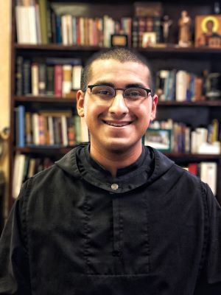

Welcome 9:15 – 9:30 a.m. (Recorded Message)

Dr. Mary Spoto
Vice President of Academic Affairs
Saint Leo University
Saint Leo, FL

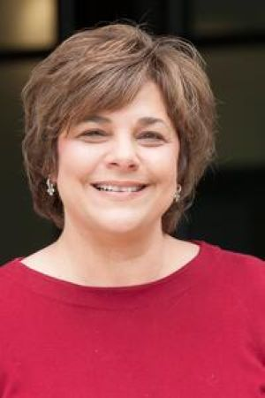

Atla Update 9:30 – 10:15 a.m.

Christine Fruin
Scholarly Communication and Digital Projects Manager
Atla

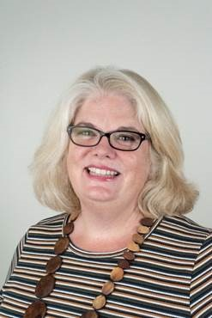

Lecture 10:15 a.m. – 11:00 a.m.

“The Eclipse of Reason: Foucault, Scientology and Why Religious Historiography (Still) Matters”

Robert J. King

Religious Studies Faculty, Faculty Training Developer, and Certified Professional Coach, American Public University System/American Military University, Philosophy Faculty, University of Phoenix ,Track and Field Coach (Throws), Northside Christian School. He uses track and field coaching to assist with performance management and professional coaching.

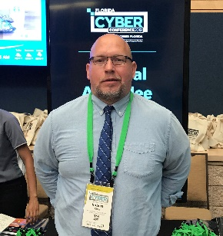

Robert J. King, was a Stuart Scholar, BA in Religion, Davidson College, Duke Scholar, Duke University, M.Div., Th.M., and studied in the Ph.D. Program in Moral Theology at the U. of Notre Dame. King has taught religion, philosophy and ethics since 2004, most recently, University of Phoenix and American Public University System-American Military University. King has received grants from N.E.H. (2010, 2011), Excellence Awards from N.I.S.O.D. (2011, 2012), an Excellence in Publishing Award (2012) and has presented as a guest lecturer at Barry University (2012), the Global Active Learning Summit, Tokyo, Japan (2017) and Harvard University (2016, 2018). His research interests specialize in U.S. religious and labor history, historiography and Aristotelian virtue ethics.

Abstract: As a religious studies professor within a military-affiliated university who regularly teaches the undergraduate course RELS452: Religious Cults, a reoccurring theme when examining New Religious Movements (from UFO cults and Scientology to Wicca and Neopaganism) is what constitutes scholarly versus apologetic sources. As based upon the historiographical description of Michel Foucault (Madness and Civilization, The Order of Things), and the content area overview of James Lewis (Controversial New Religions by Oxford University Press), the question of religious epistemology will be examined. Both within teaching about New Religious Movements, but also in guiding U.S. military and other national and international security personnel to research protocol aligned to their respective professional duties, careful use of sources that is open, yet precise in classification as scholarly or apologetic, is necessary to avoid bias or counter-bias. Thus, as a specific case study example, historical claims made by Scientology will be compared, to and analyzed from, a historiographical framework as described by Michel Foucault in order to demonstrate how New Religious Movements can be evaluated charitably, yet critically.

Lecture 11:00 a.m. – 11:45 a.m.

“Student Use of Library Books at St. Vincent de Paul Regional Seminary: An Exploratory Study”

Arthur G. Quinn
Director of Library Services
St. Vincent de Paul Regional Seminary
Boynton Beach, FL

Ethan J. Allen
Retired Librarian and Volunteer
Florida Atlantic University
Harbor Branch Oceanographic Institute
Ft. Pierce, FL
Volunteer Cataloger
Benedictine Monks of Norcia (Italy)
Volunteer
Archives of St. Vincent de Paul Regional Seminary
Boynton Beach, FL
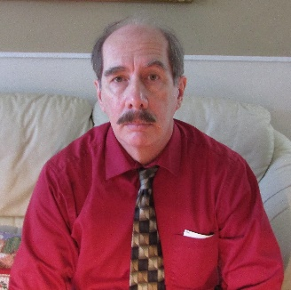

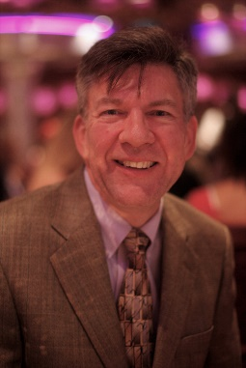

Arthur G. Quinn has been director of library services at St. Vincent de Paul Regional Seminary in Boynton Beach since 1996. He holds an MS in Library Science from FSU (1996) and a Specialist degree in Educational Leadership from FAU (2007). He is one of the founding members of FTLA and has hosted conferences in 2003 and 2014.

Ethan J. Allen recently retired from Florida Atlantic University Libraries at the Harbor Branch Oceanographic Institute, Ft. Pierce. In his last assignment he interviewed marine science researchers and faculty for the purpose of discovering their library resource and service needs. Another project was to complete a collection analysis in terms of age, use, holdings comparison with peer institutes, and overall relevance to graduate ocean science and nursing programs. Ethan holds graduate degrees in theology (Collegeville, MN) and library science (USF).

Abstract: In recent years academic libraries have been reporting both shrinking requests for reference service and lower circulation data for print collections. This downward circulation trend was investigated within specific areas of the print book collection at St. Vincent de Paul’s Oscar C. Shorp Library. Check outs of print material in the subject areas of Sacred Scripture remain strong relative to lesser use of materials in the other core curricular areas of philosophy, systematic theology, and liturgy. This study examines circulation data for the aforementioned subject areas in the academic year 2018/2019 and assesses survey responses from faculty who instruct in these specializations. The faculty survey revealed an array of topics for student papers, reading lists, and professors’ own use of the library. Additional data from the survey suggested how services and materials might be surveyed for future assessment. The study brings fresh insight to the alignment of the collections to the curriculum while setting a baseline for data collection that reflects usage trending.

Lunch and Networking 11:45 a.m. – 12:45 p.m.

Lecture 12:45 p.m. – 1:30 p.m.

“Using Periodical Index modules of International Library OPACs to find References to Roman Catholic Spanish Language Theological Journal Articles”

Philip M. O’Neill
Senior Reference and Instruction Librarian
Barry University
Miami Shores, FL
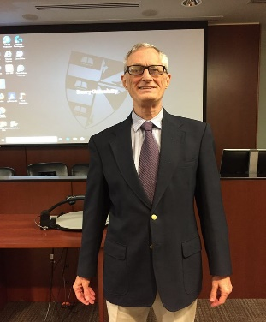

Philip M. O’Neill is Senior Reference and Instruction Librarian at the Monsignor
William Barry Memorial Library, Barry University in Miami Shores, FL.
He is the subject specialist for Theology, Philosophy, History, Political Science,
Business, and Economics. He received his M.S. in Library Service from Columbia
University (1977) and his B.A. in History from the University of Delaware (1975).

Abstract: It is difficult to find indexing of Spanish Language Theological Journals. The Atla Religion Database with Atla Serials PLUS does index a few of these periodicals. Index Theologicus also indexes a number of peer-reviewed journals in this language. This presentation will examine the indexing of Roman Catholic periodicals by the OPACs (Online Public Access Catalogs) of libraries in Spain and in Latin America.

The Day’s Program will end at 1:30 p.m.

