

Add your information here

Add your information here

Add your information here

Add your information here

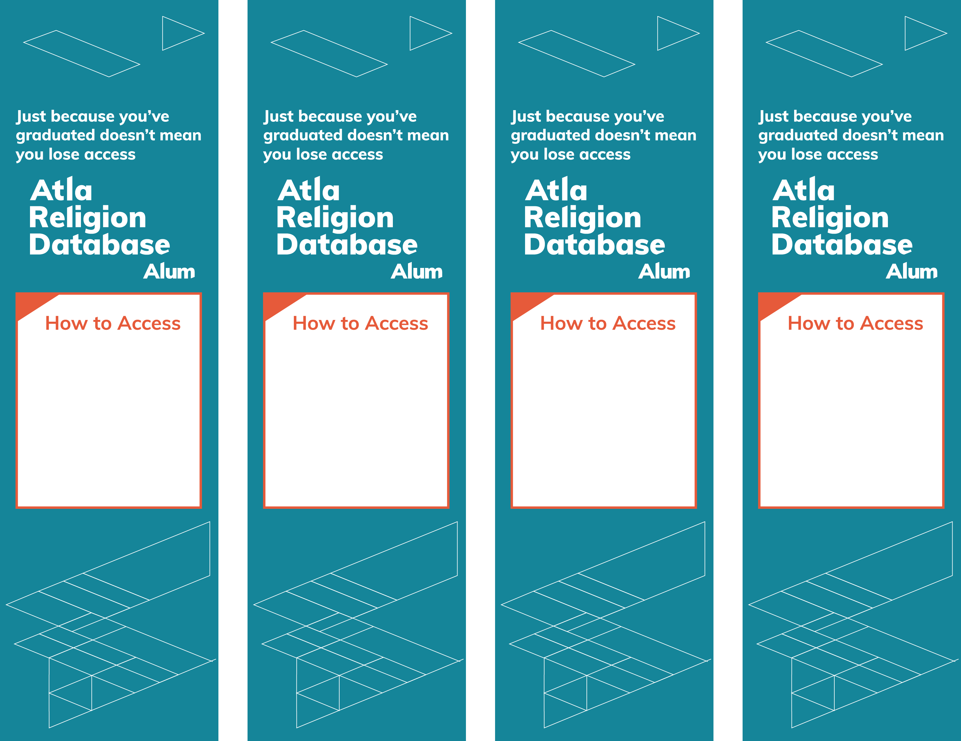

Add your information here

Add your information here

Add your information here

Add your information here